POLICE STATION DATABASE

FEATURES

POLICE

CRIMINALS

UNDER FIRST FEATURE

POLICE INFO

1. policeid (PK) - it is the primary key

2. name

3. phonenumber

4. dob

5. city

6. Address

7. gender

8. policestatusid(FK)- it is the foreign key which is referenced from the policestatus table.

9. stationid (FK) - it is the foreign key which is referenced from the station table.

POLICE STATUS

1. policestatusid (PK) - it is the primary key

2. policestatusname (UK) - it is the unique key

3. police income

4. description

STATION INFO

1. stationid (PK)

2. stationname

3. stationcity

4. stationphonenumber

5. address

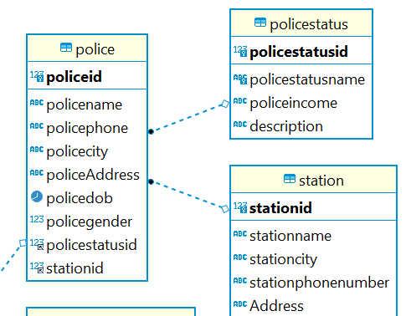

UNDER SECOND FEATURE

CRIMINAL INFO

1. criminalid (PK)

2. criminal name

3. criminal phno

4. criminal city

5. homeaddress

6. DOB

7. gender

2. CRIMES

1. crimesid (PK)

2. Crimename

3. crimecategory

3. CRIME INCIDENTS

1. incidentid (PK) - it is the primary key

2. Policeid (FK) - it is the foreign key referenced from police table

3. Criminalid (FK) - it is the foreign key referenced from the criminal table

4. Crimesid (FK) - it is the foreign key referenced from the crimes table.

5. Incidentdate

6. incidentoccuredlocation

4. gender

1. genderid (PK)

2. male boolean

3. female boolean

The gender table is the meta data along with the crimes table and crimeincident table.

